**\*Building a Face Detection App on AWS using Amazon Rekognition\***

* **Ethnus CodeMithra 7 day MasterClass webinar**
* **AWS webinar : Day 4 to Day 7**
* **27th March 2020 to 30th March 2020**

**Student Name :** Swapnil Gopal Ghardale

**Email :** [ghardaleswapnil@gmail.com](mailto:ghardaleswapnil@gmail.com)

**College :** Nutan Maharashtra Institute of Engineering and Technology, Pune, Maharashtra, India

**Department :** Computer Engineering

**Year :** TE

**Batch :** 2017-2020

Screenshots of the created project are attached below:

**SCREENSHOTS**

**Screenshots for Dashboards**

1.AWS Login screen with username

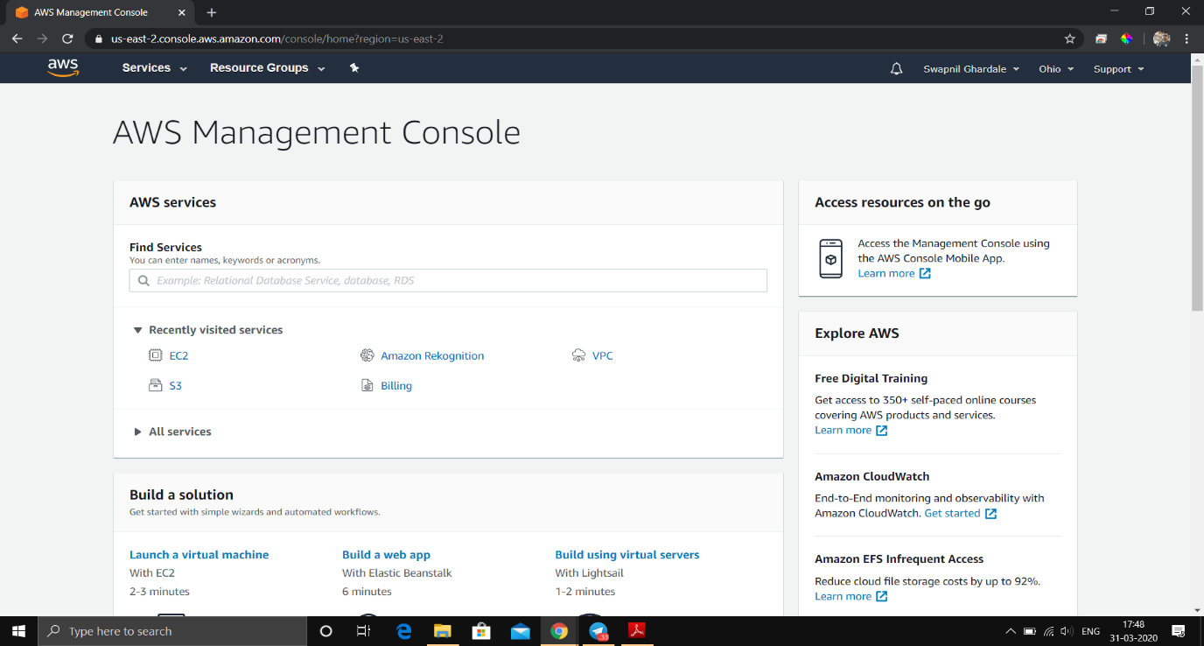

2. EC2 Dashboard

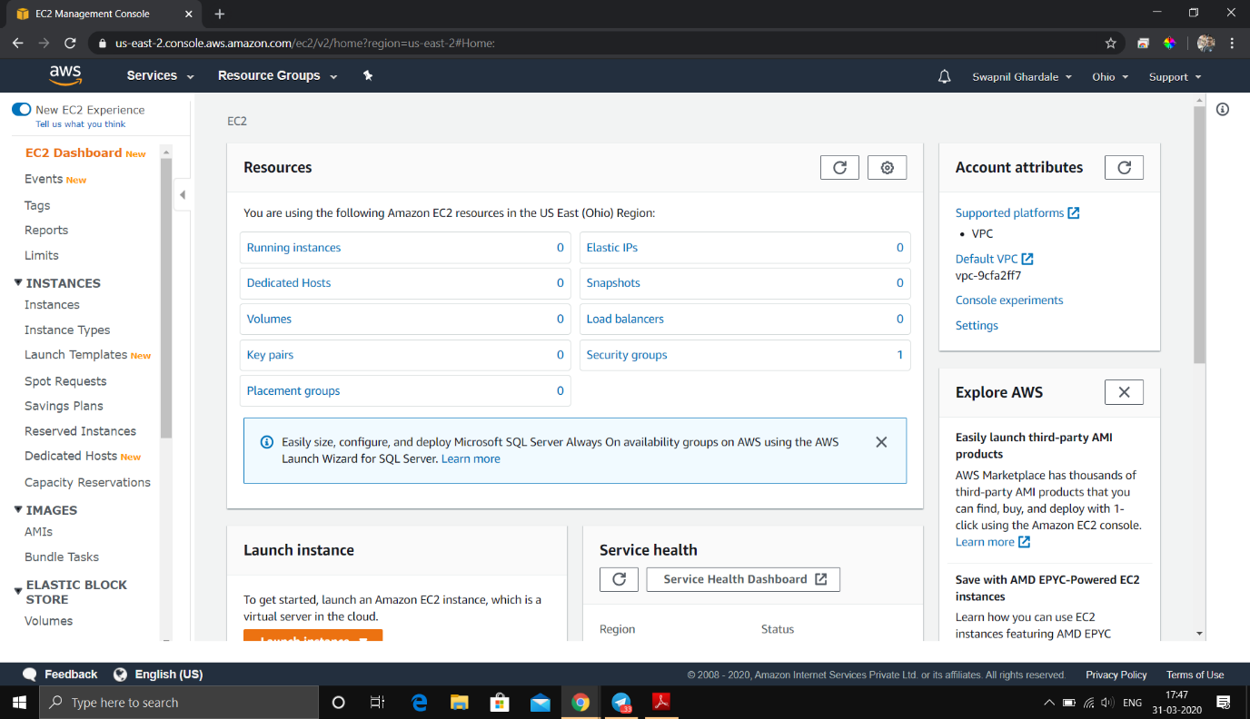

3. S3 Dashboard

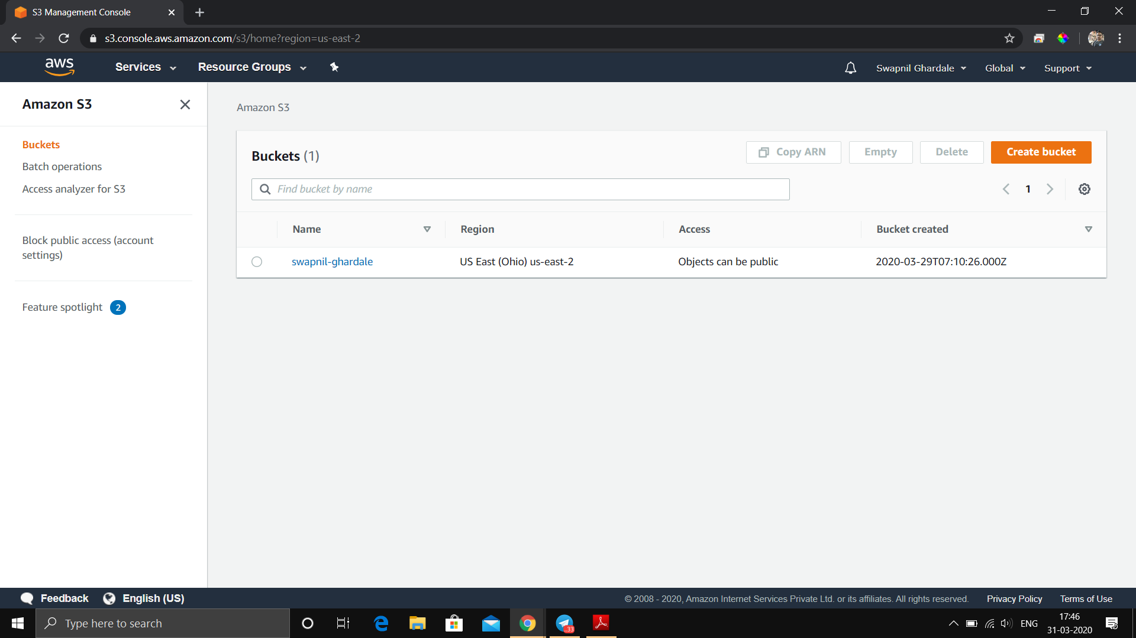

4. Rekognition Dashboard

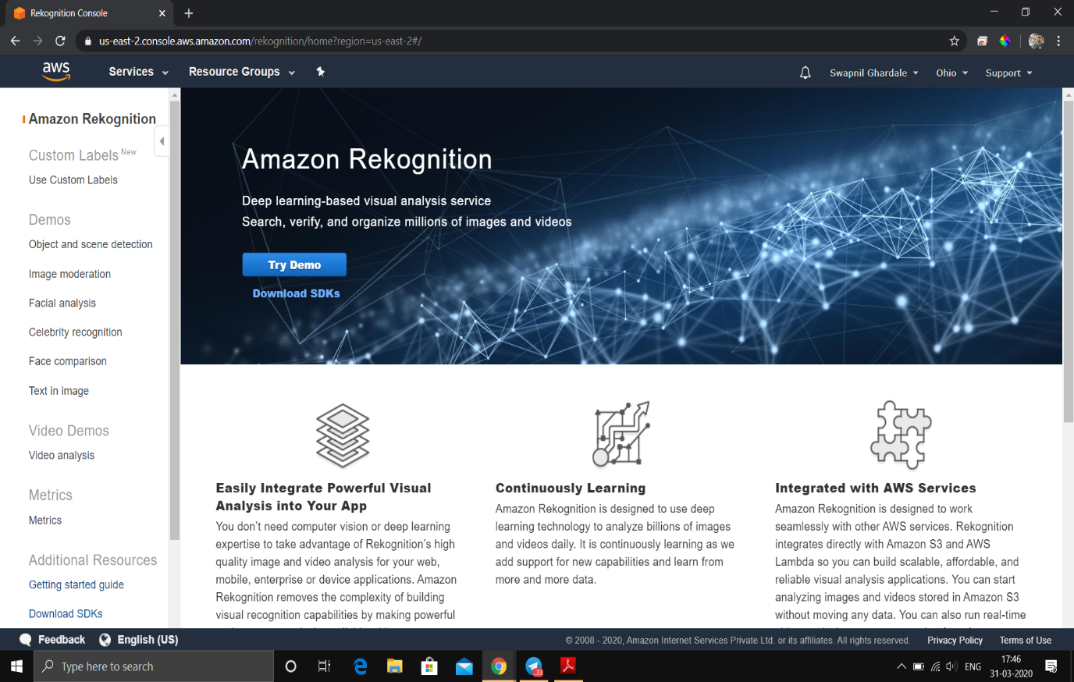

**Screenshots for EC2**

1.Choosing an AMI

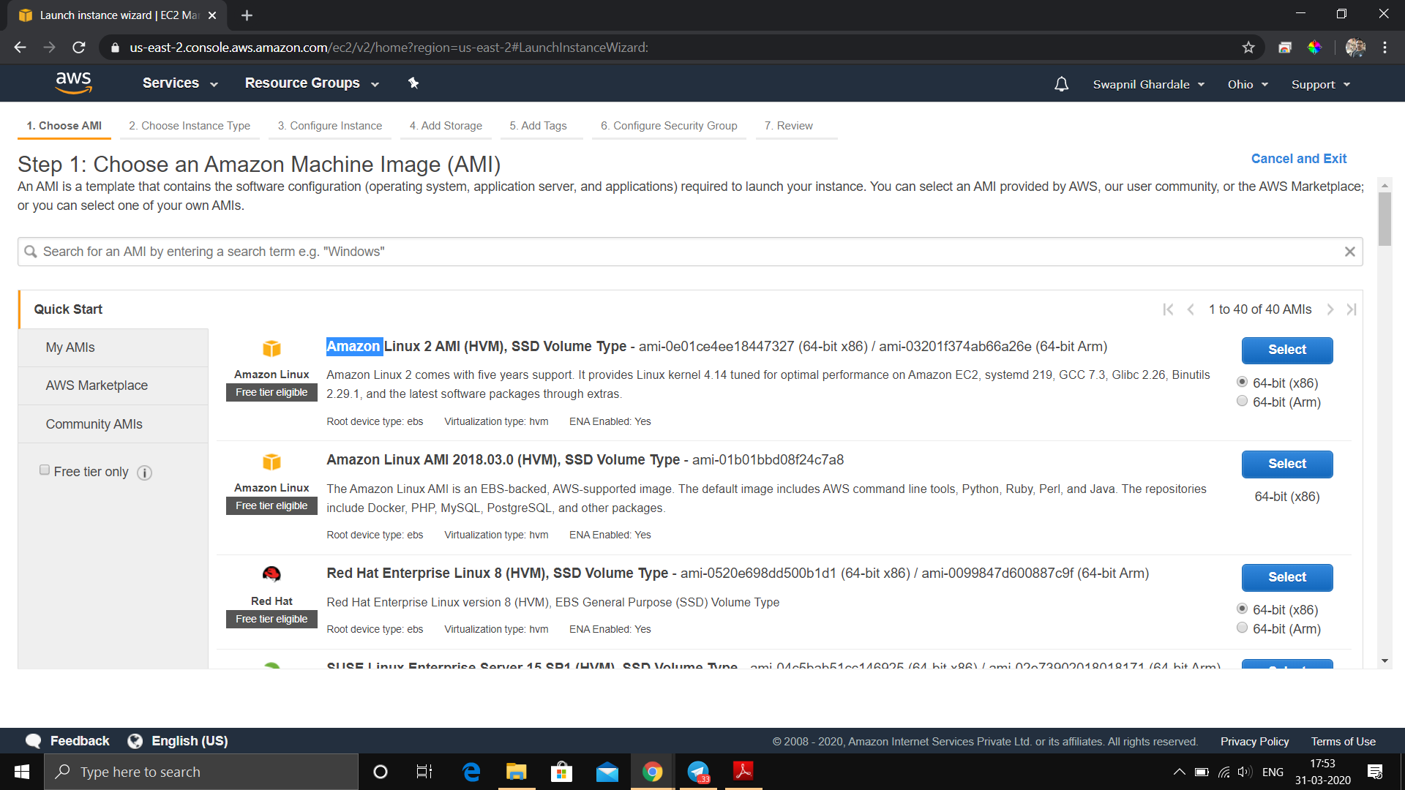

2. Choosing an Instance Type

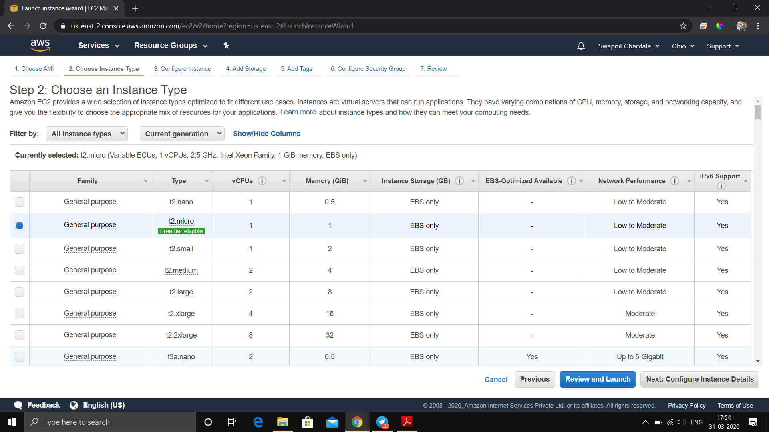

3. Adding Storage

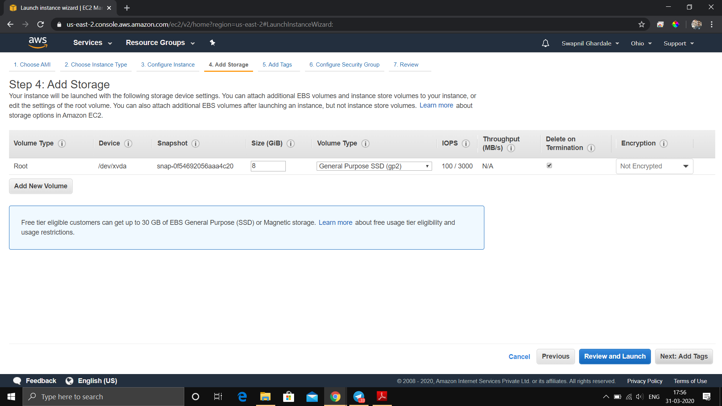

4. Configuring Security Group

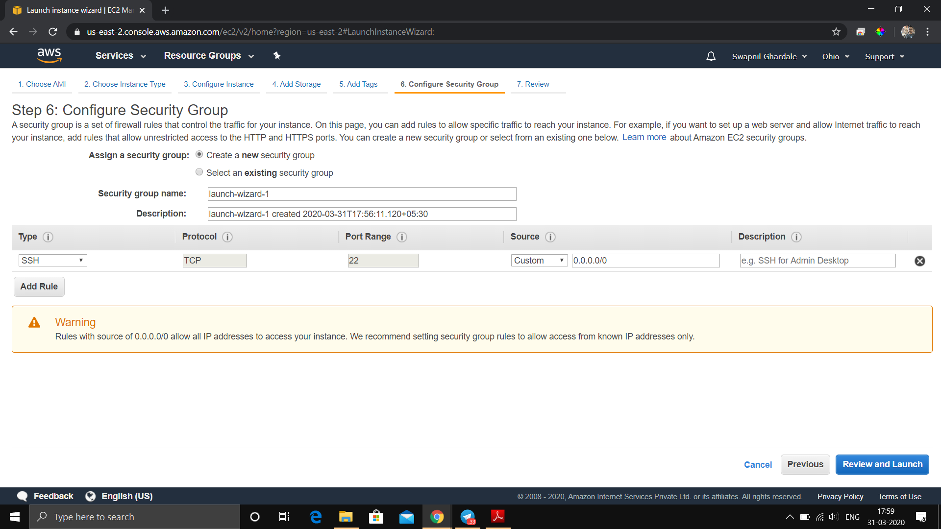

5. Key Pair Download

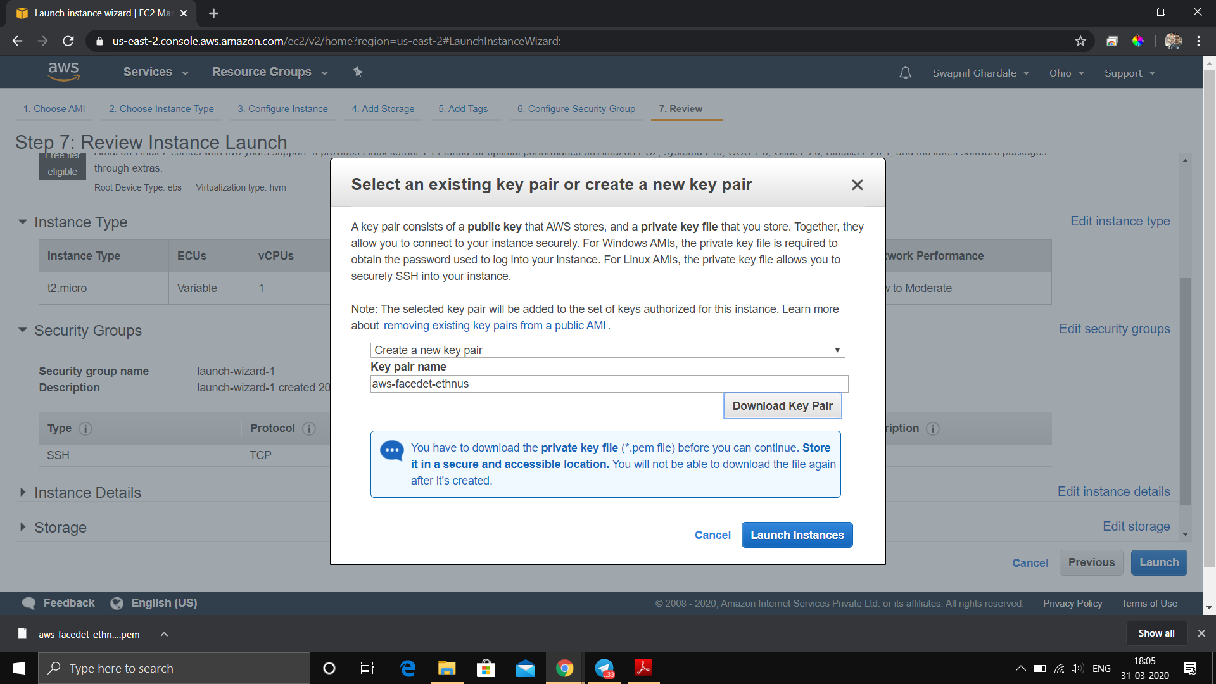

6. PuTTYgen conversion from pem to ppk

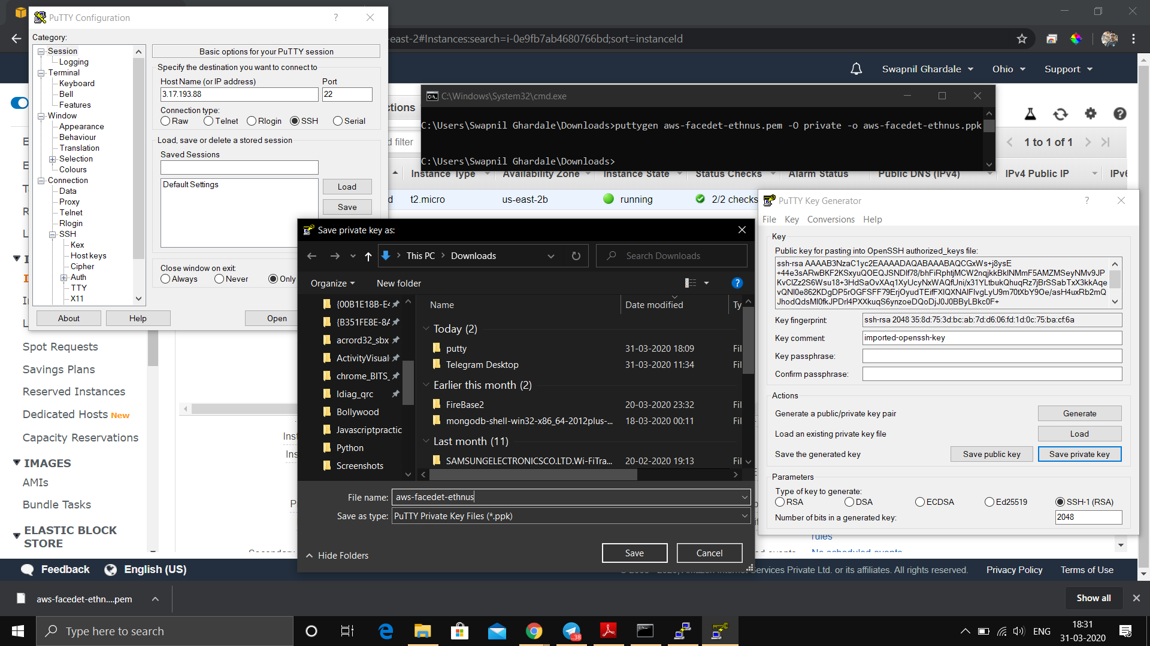

7. Logged in EC2 black screen

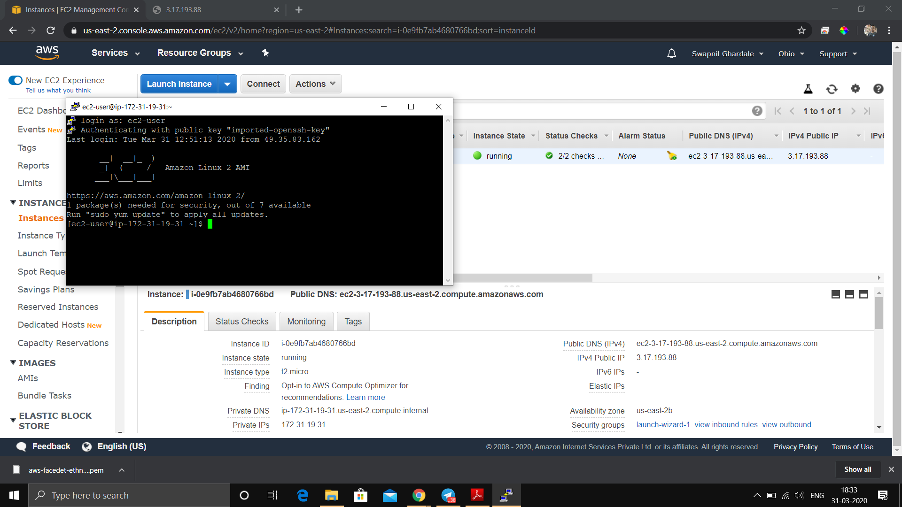

EC2 Dashboard after creating instance

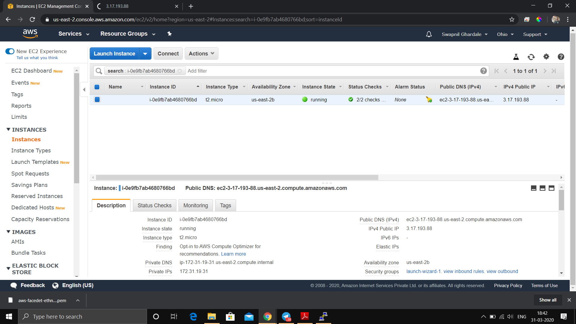

**Screenshots for S3**

1. Creating a bucket

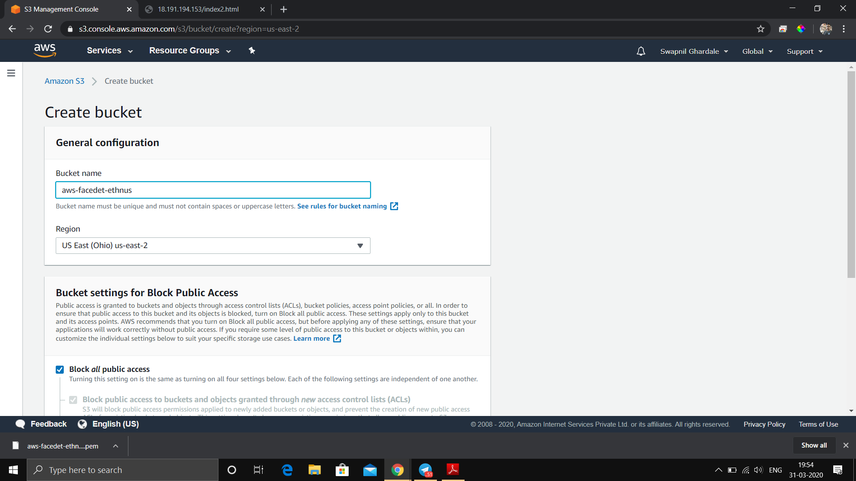

2. Uploading an Object

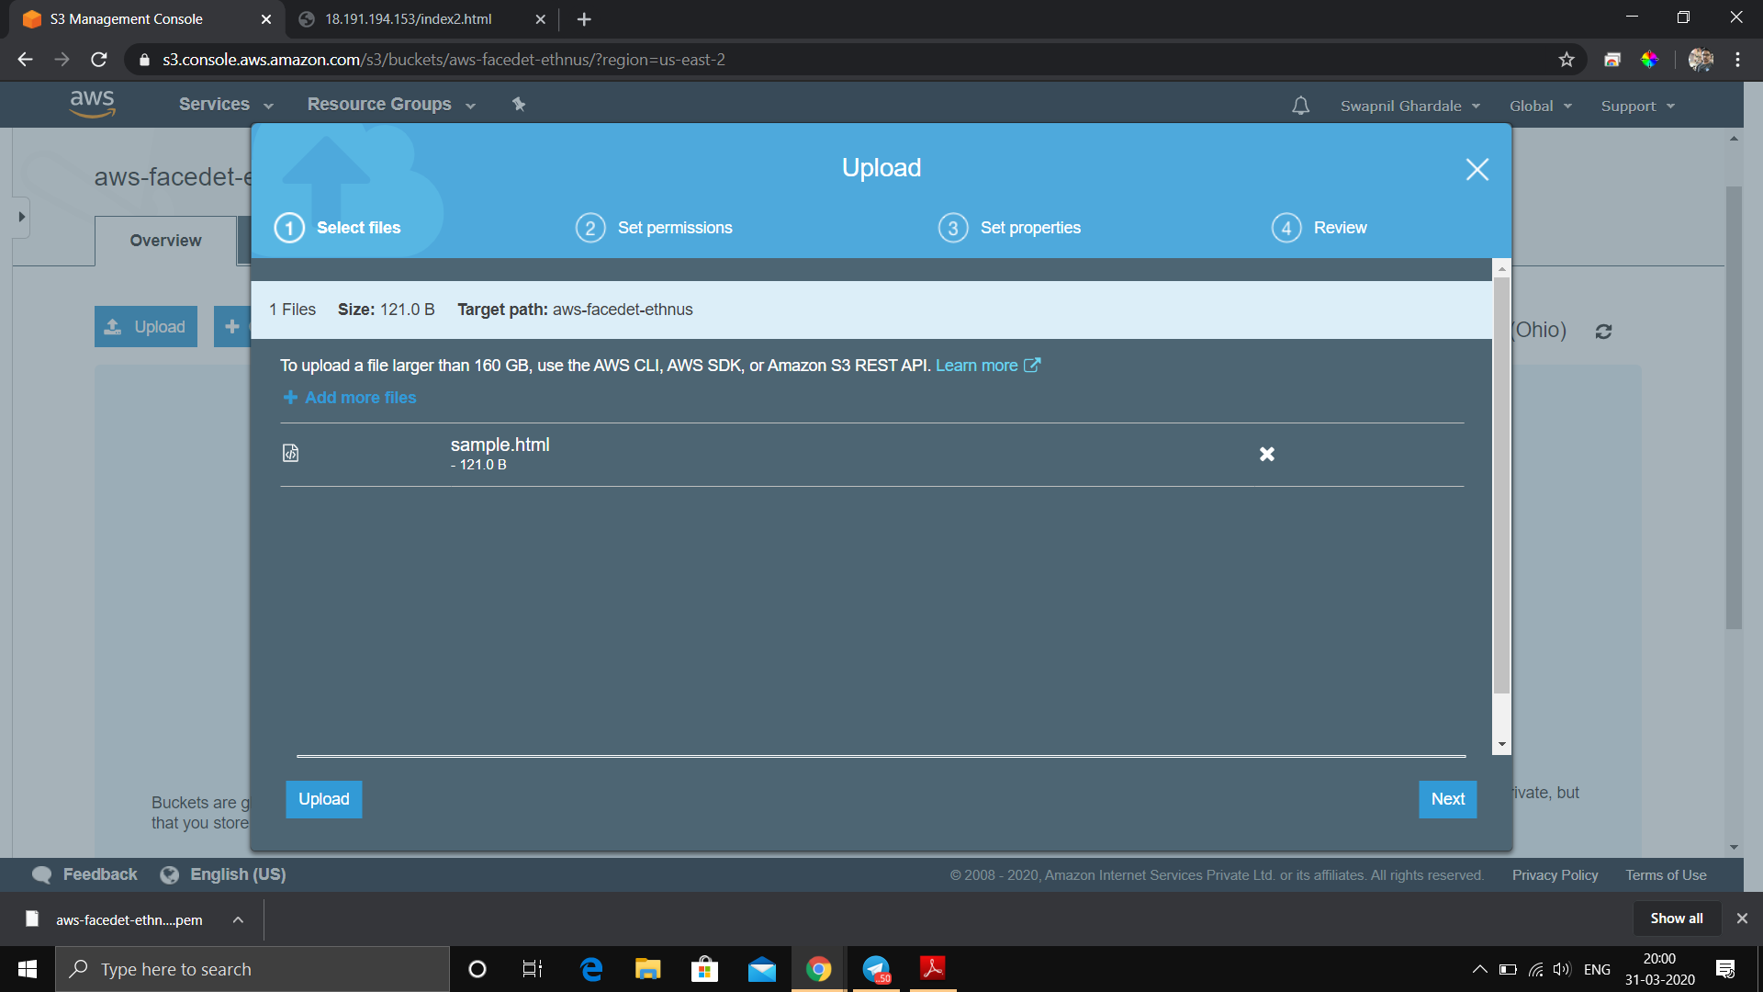

3. Enabling Static Website

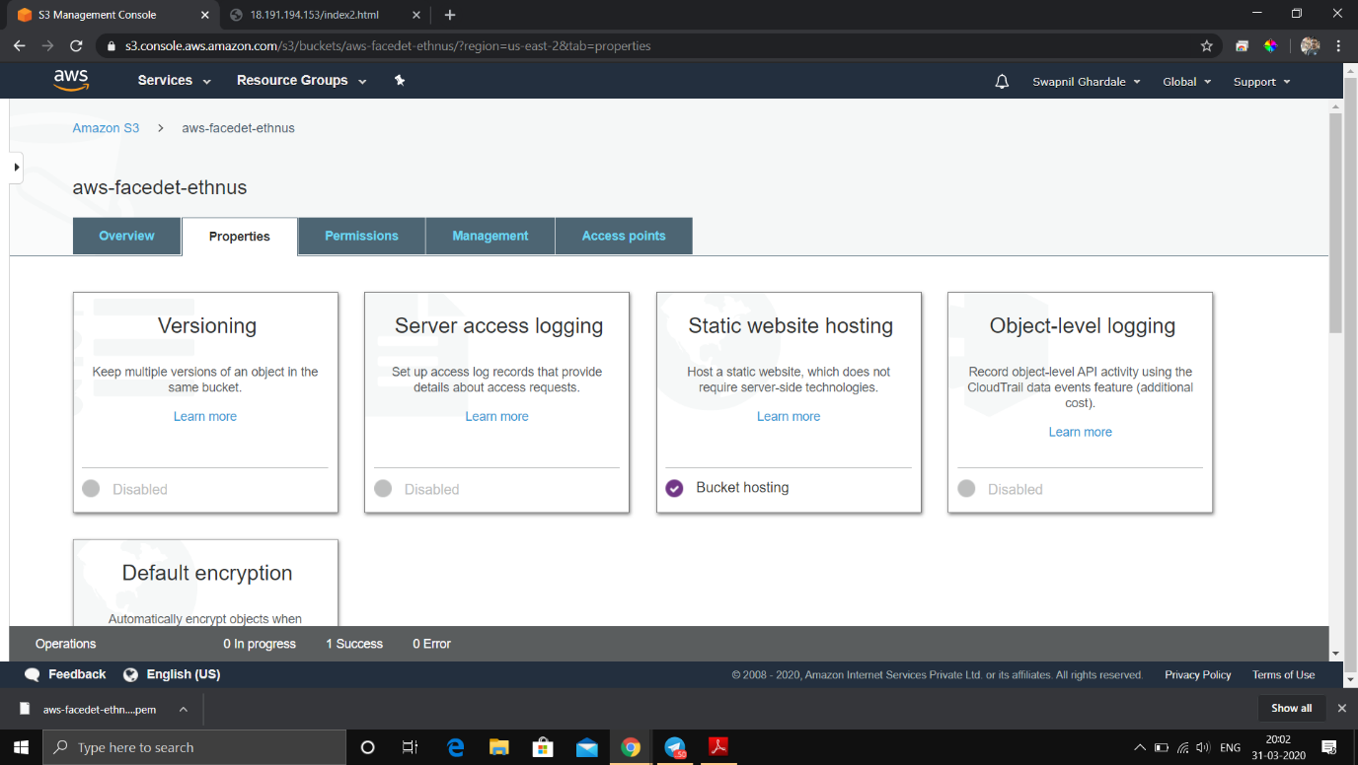

Making Bucket to unblock public access

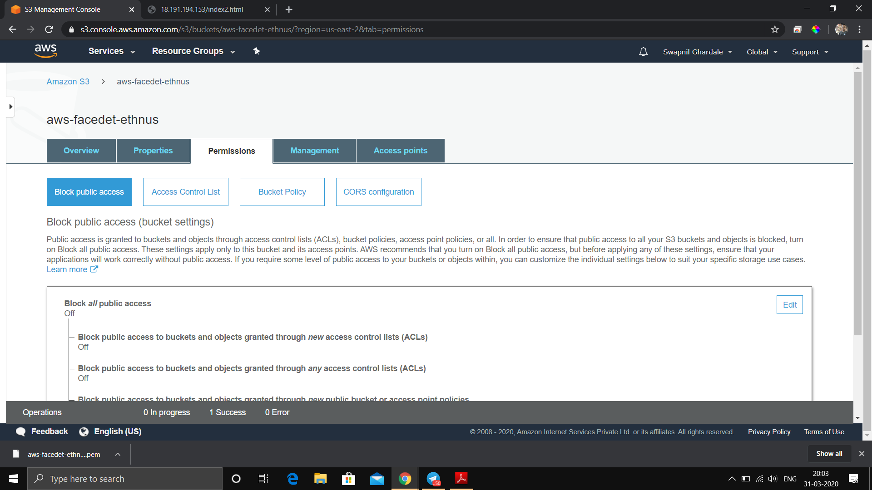

4. Making the Object Public

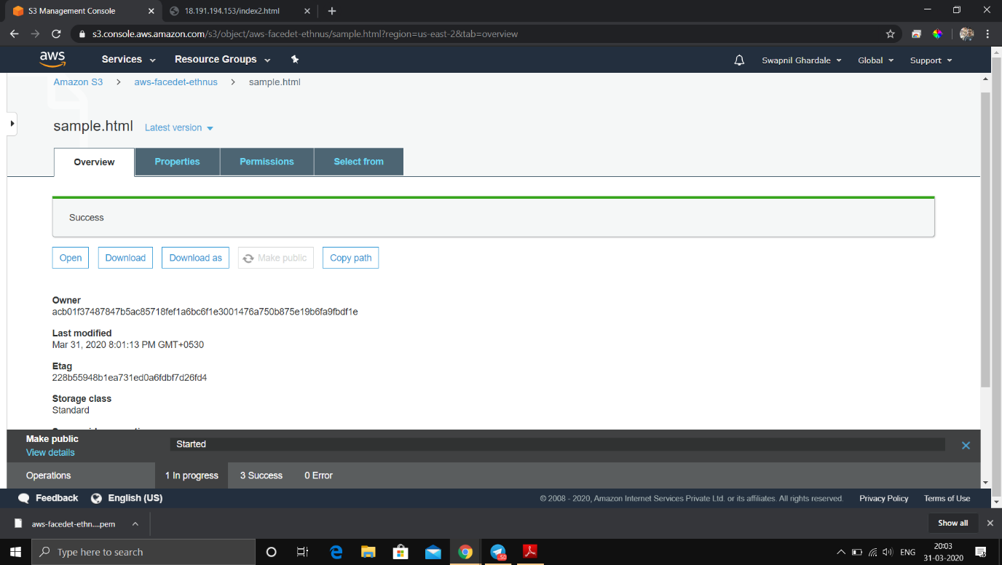

5. Checking the S3 link on the browser



S3 Dashboard after creating bucket

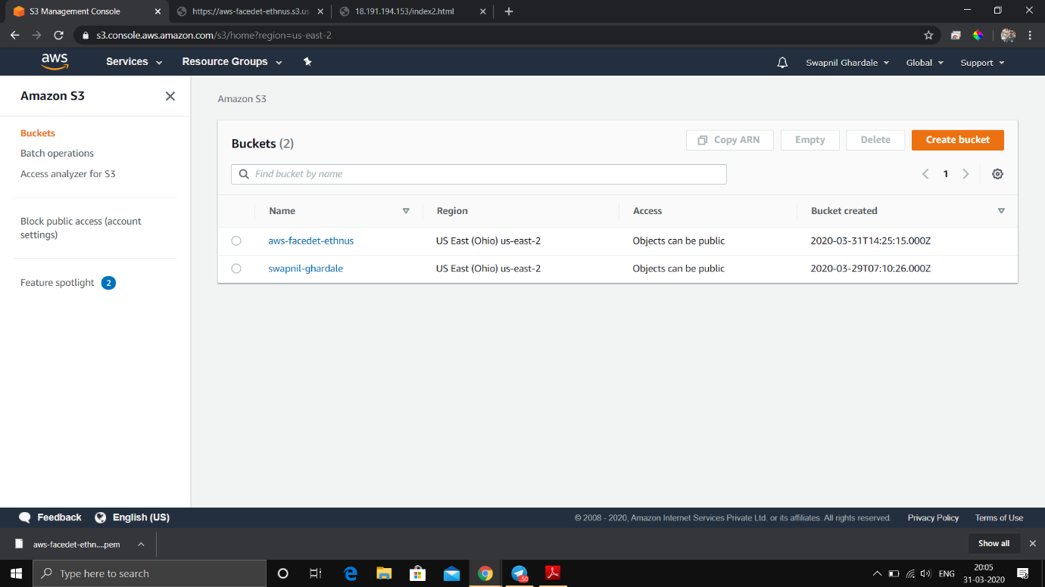

**Screenshots for Rekognition**

1. Face Detect / Analysis

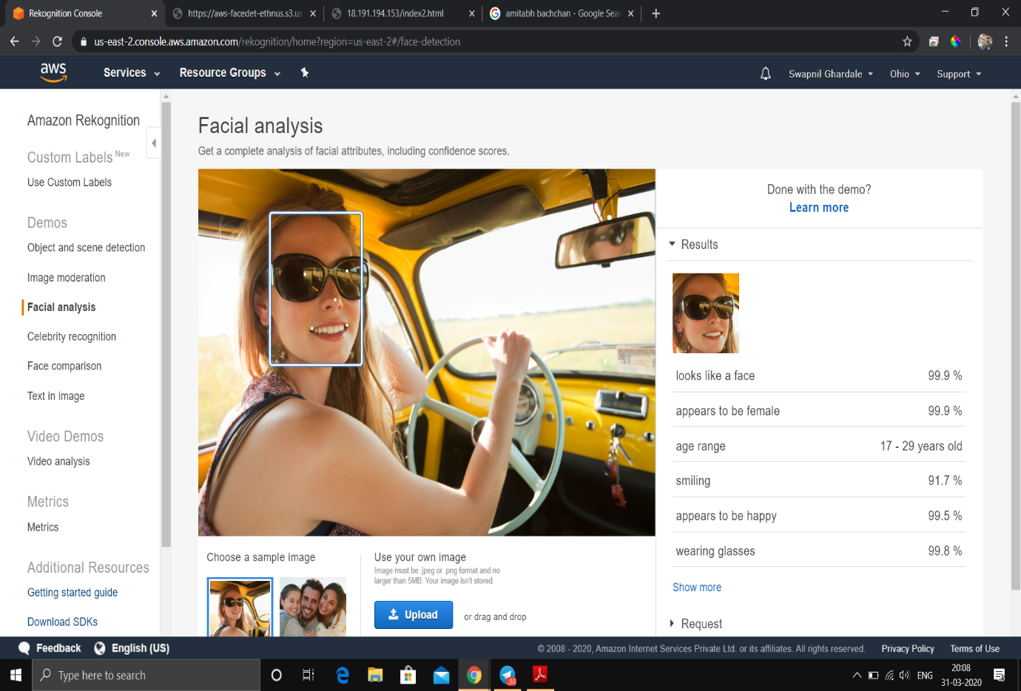

2. Face Compare

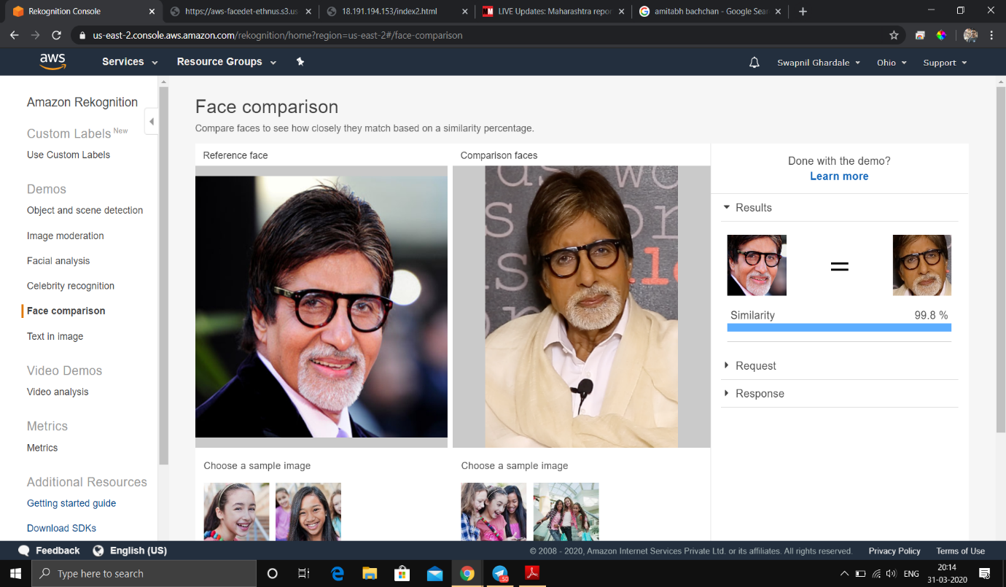

3. Celebrity Recognition

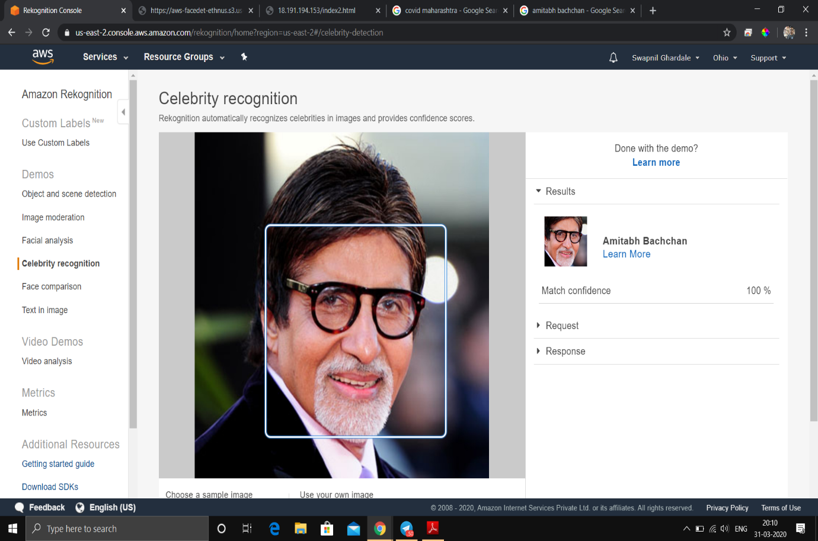

4. Text in Image

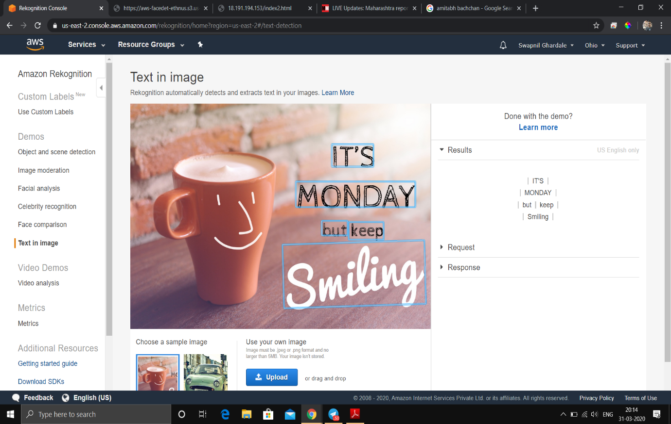

**Screenshots for EC2 & S3**

1. Installing php

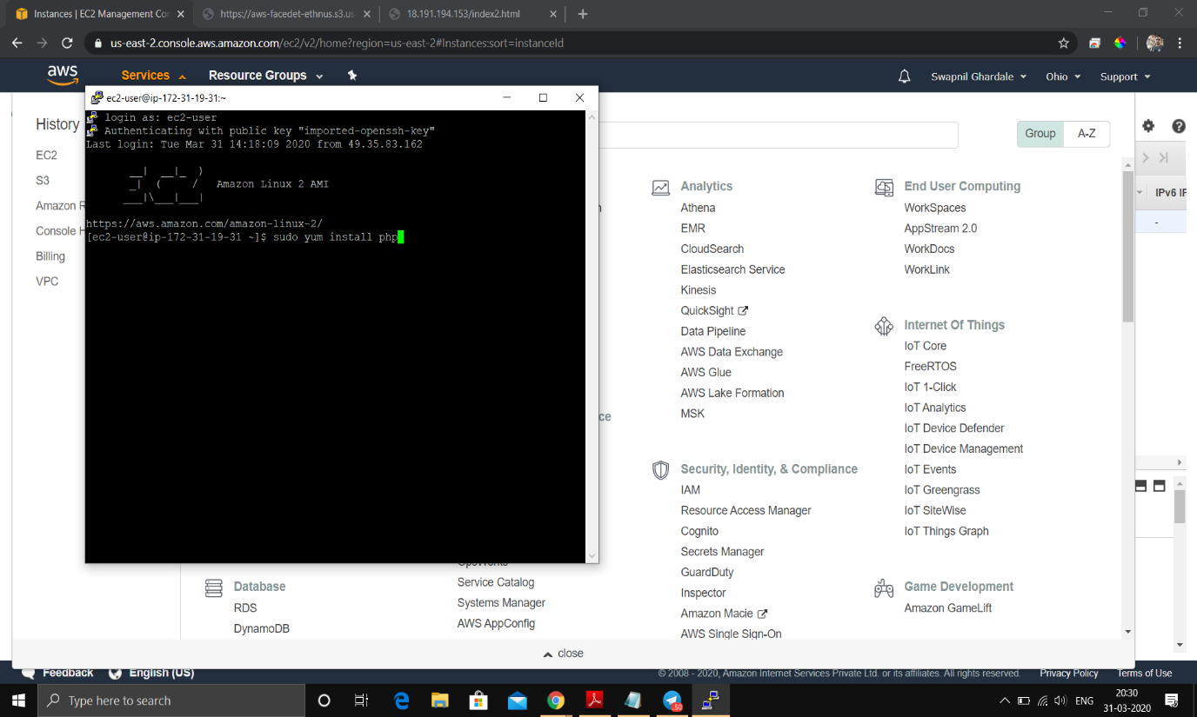

2. Installing aws-sdk - part1

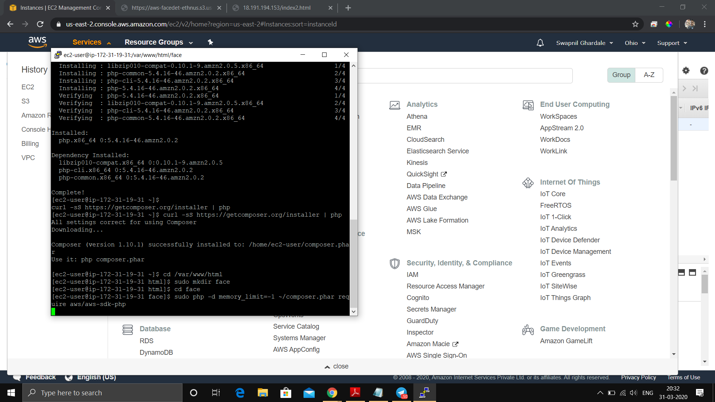

Installing aws-sdk - part 2

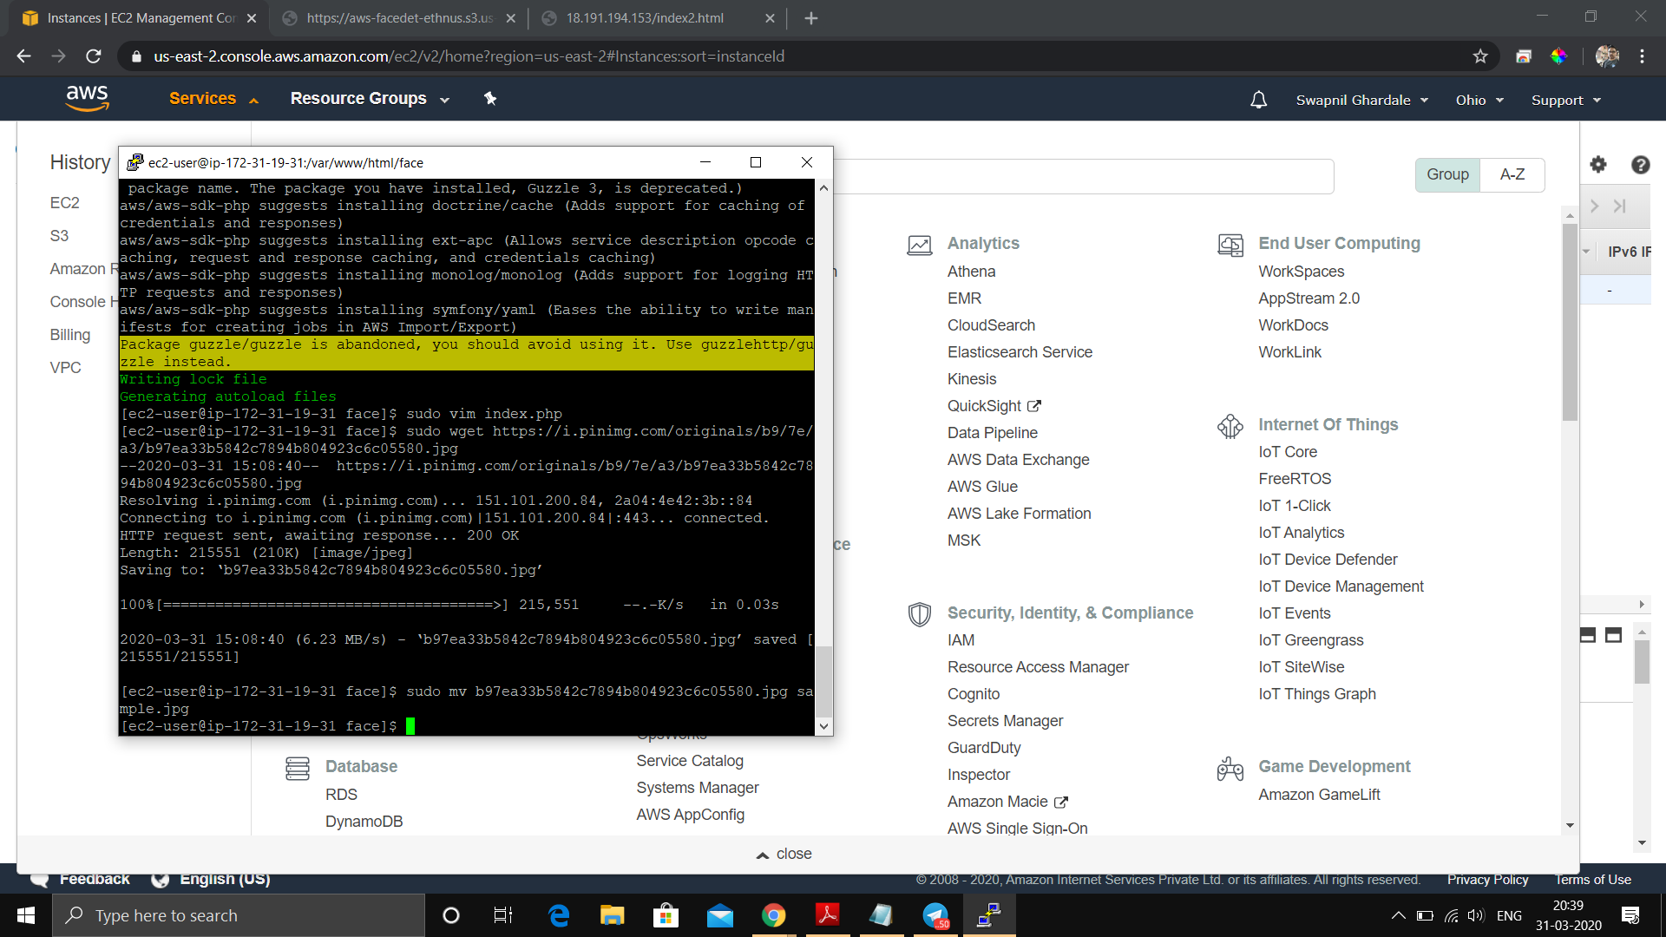

3. index.php file code

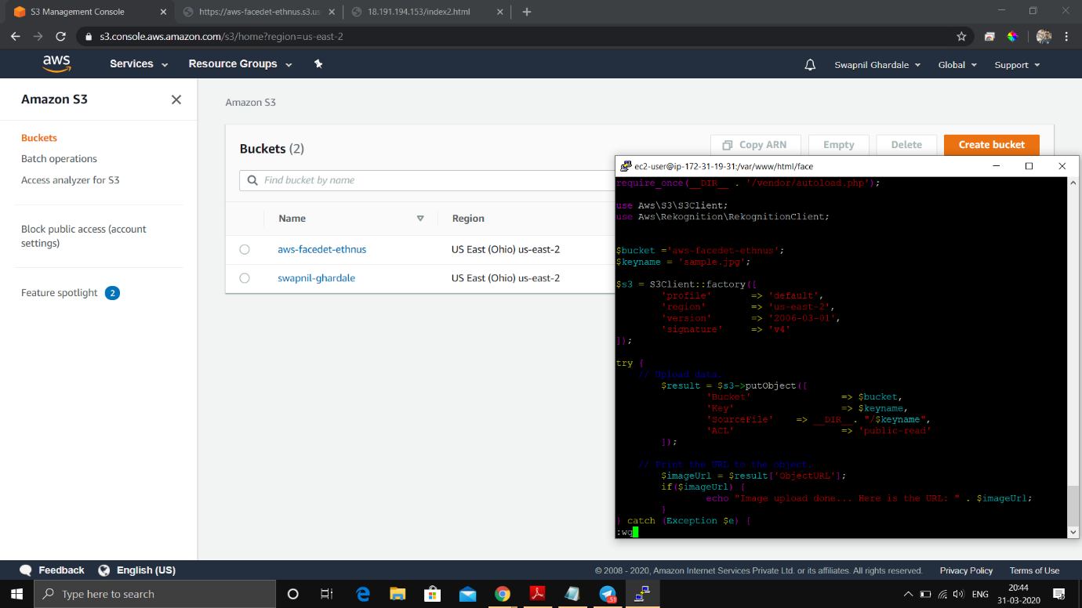

4. Upload success screenshot

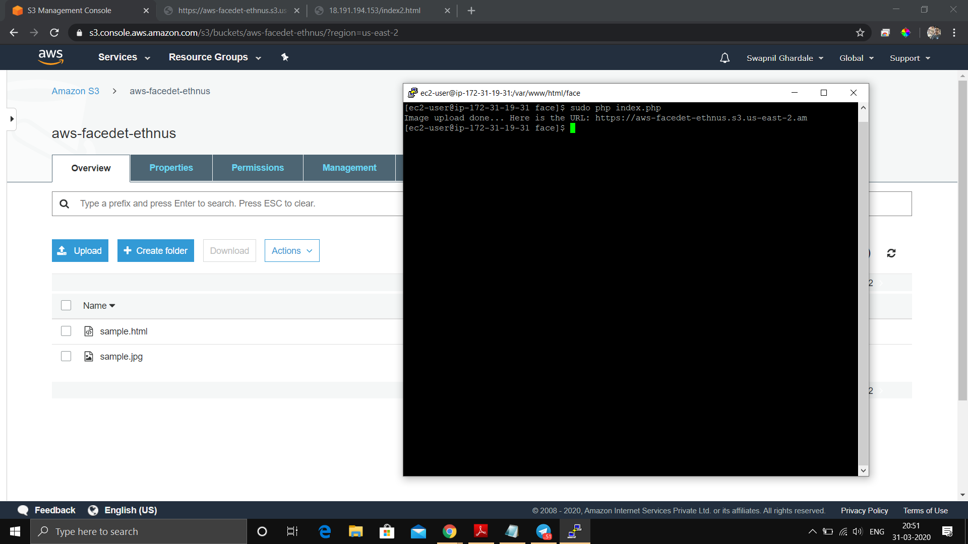

*NOTE: As we stop and restart the ec2 instance the public DNS and public IPv4 Address gets changed, keeping the private address same for particular instance.

In this case, I have stopped and restarted the instance which changed instances’ public IPv4 address but the private IP address remains same.

**Screenshots for EC2 & Rekognition**

1. Face Detect success screenshot

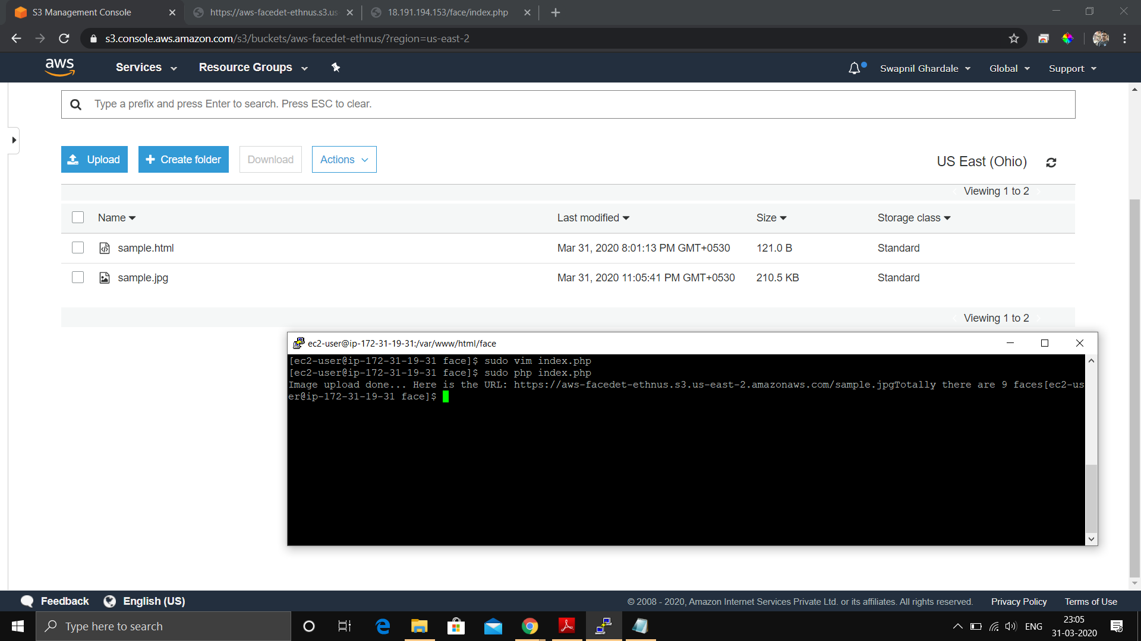

Updated index.php with Rekognition function invoked.

